6.67: a) 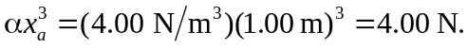
b) 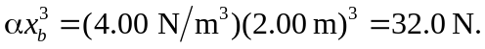 c) Equation 6.7 gives the work needed to move an object against the force; the work done by the force is the negative of this,
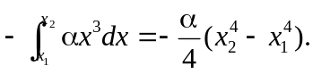
With 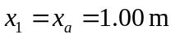 and 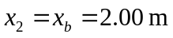, 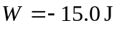, this work is negative.

